Data Extraction from Handwritten Medical Documents
A hybrid OCR and LLM-powered pipeline for extracting structured information from handwritten and printed medical documents such as prescriptions, clinical notes, and admission records.
Features
1 . Converts PDF and image-based medical documents into structured JSON.
2 .Uses PaddleOCR and EasyOCR (for printed text) and Tesseract (for handwritten text).
3 . Automatically detects handwritten vs printed regions.
4 . Cleans and enhances input images using OpenCV.
5 .Enriches extracted data into a structured schema using Gemini Model
6 .Stores embeddings in a Chroma VectorDB for fast semantic search.
7 .Generates a Prover JSON file with complete metadata and provenance.
Architecute Flow
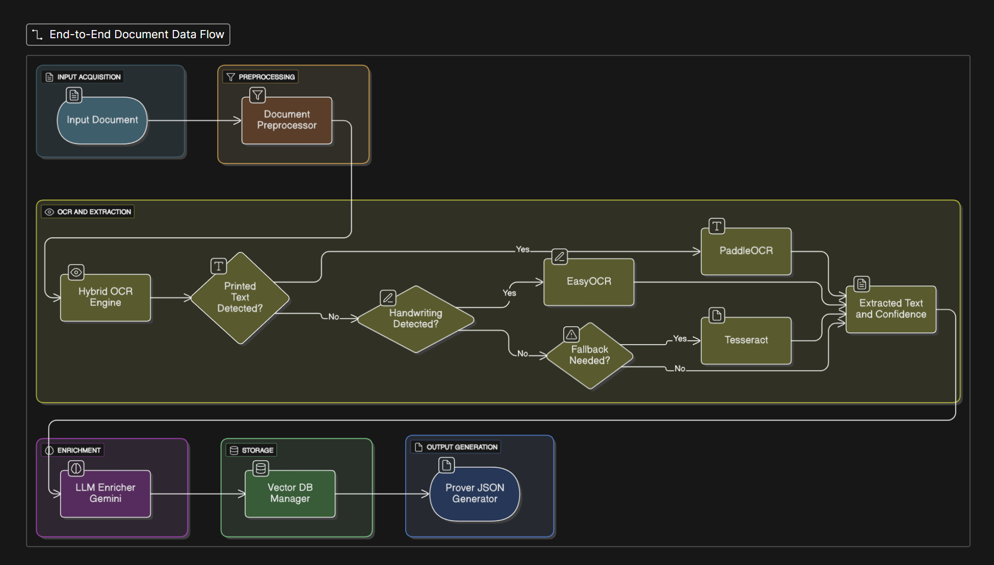

Installation (Local setup)
git clone https://github.com/Ajay-308/data-extraction-from-hand-written-image.git
cd data-extraction-from-hand-written-image

create virtual python env with python 3.9 to 3.10 because paddleOCR is not supported in above version of python
python3.10 -m venv venv
source venv310/bin/activate # or venv310\Scripts\activate on Windows
pip install -r requirements.txt

If PaddleOCR or Tesseract fails to load, install:
sudo apt-get install -y tesseract-ocr libgl1-mesa-glx

for running it
streamlit run app.py

Here is my google collab file u can refer that too :- Colab Demo
If you are running in your collab just to make sure u have all these dependenceis downloaded.
!apt-get update -qq
!apt-get install -y -qq tesseract-ocr
!pip install -q paddleocr paddlepaddle sentence-transformers chromadb google-generativeai pytesseract PyMuPDF opencv-python-headless Pillow tqdm

In this project, I used Gemini 2.5 Flash along with PaddleOCR, EasyOCR, and Tesseract for extracting and interpreting data from handwritten medical images.
The Gemini 2.5 Flash model achieved an average confidence score of approximately 45.2%, whereas the Grok LLaMA model delivered significantly lower performance, with an average confidence score of around 24.8% on the same dataset.
UI Image
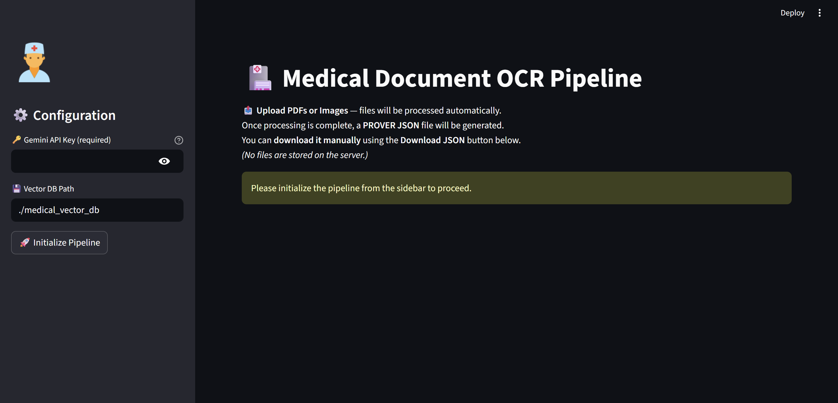

After pipeline initialization
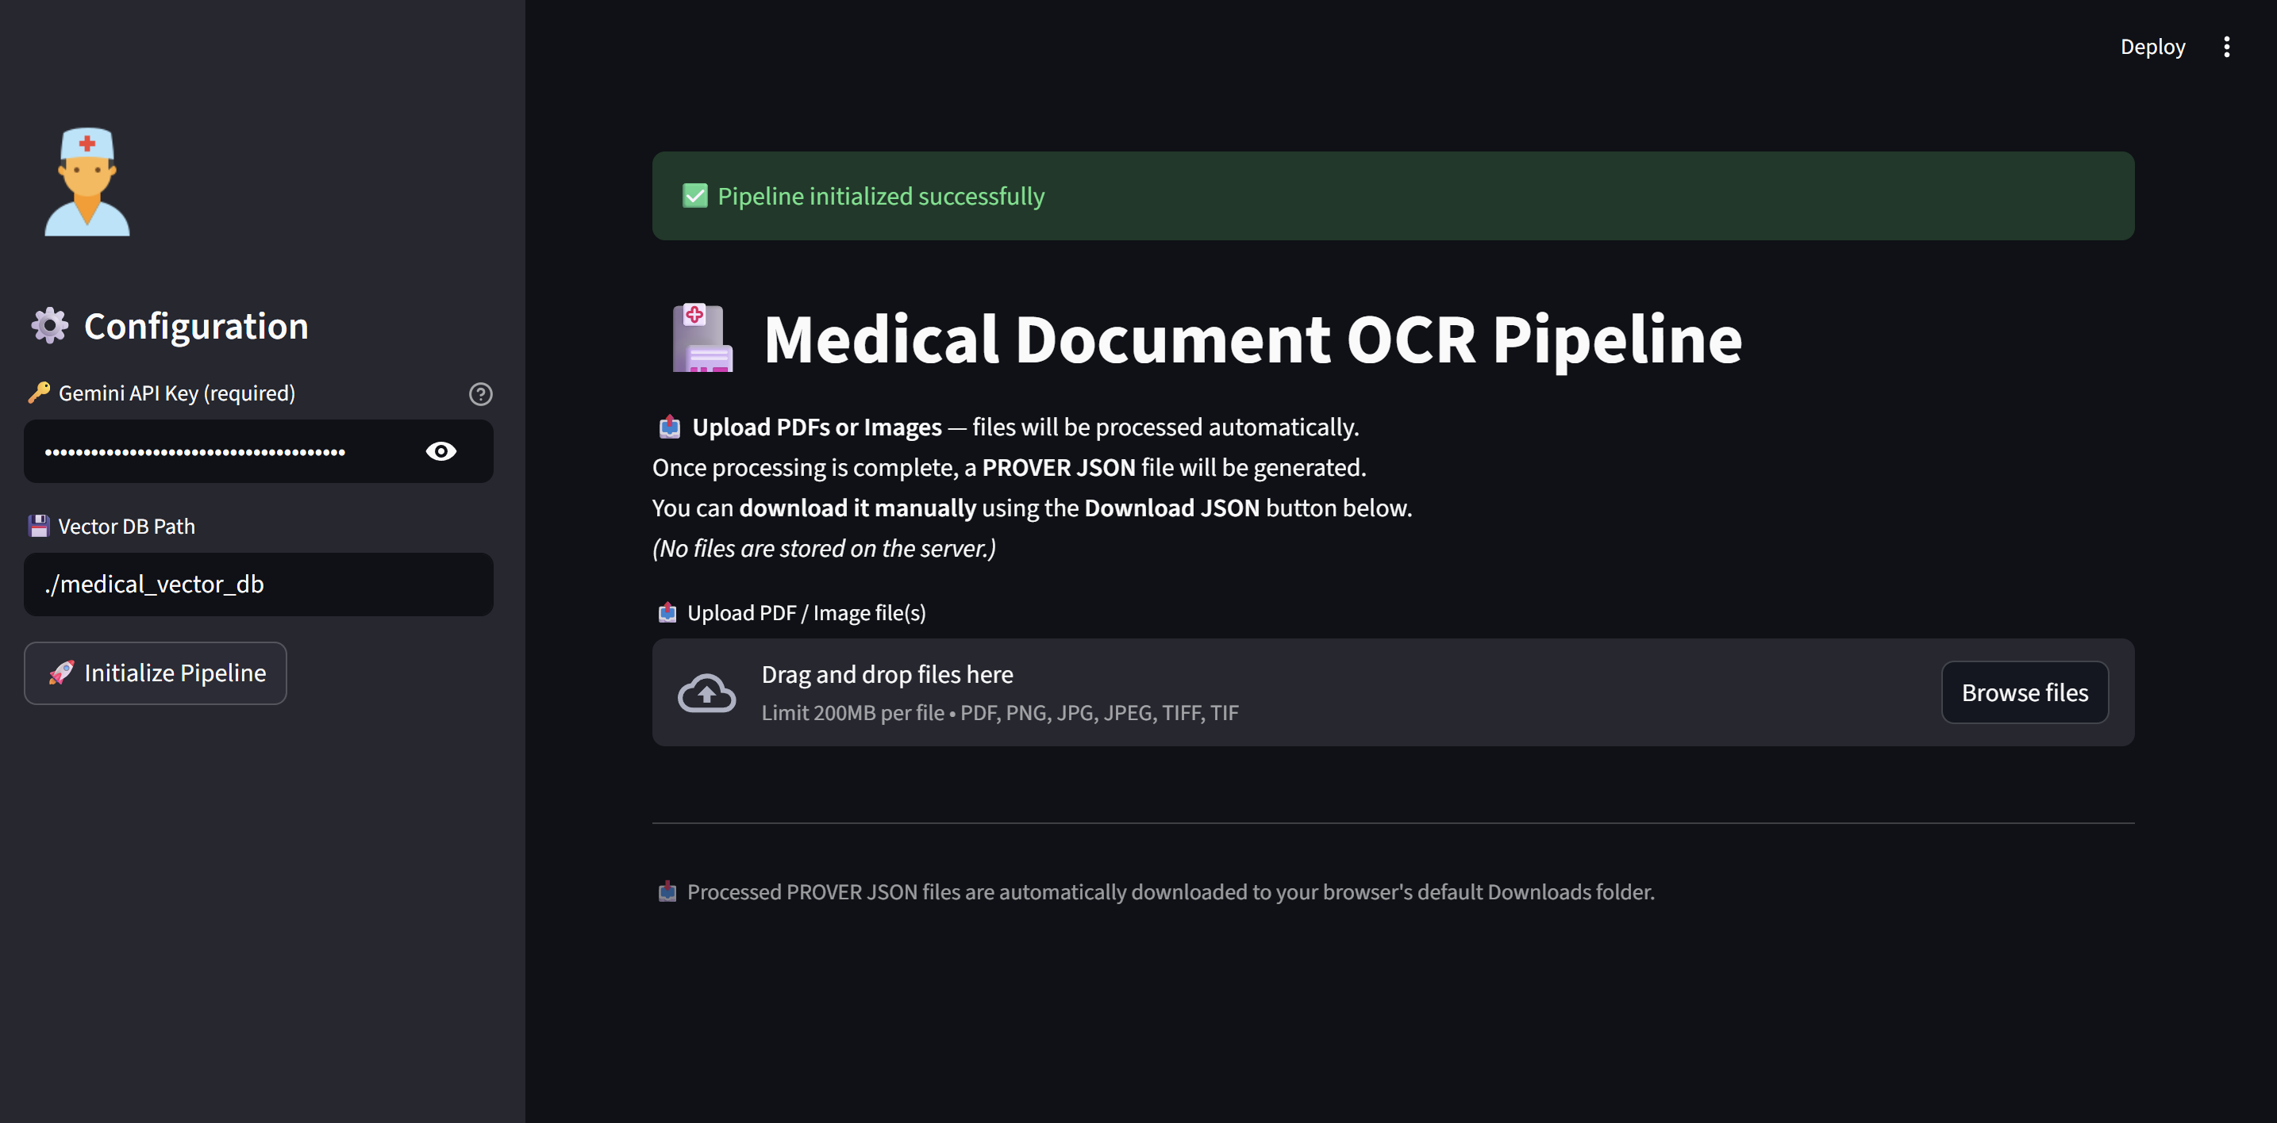
Final
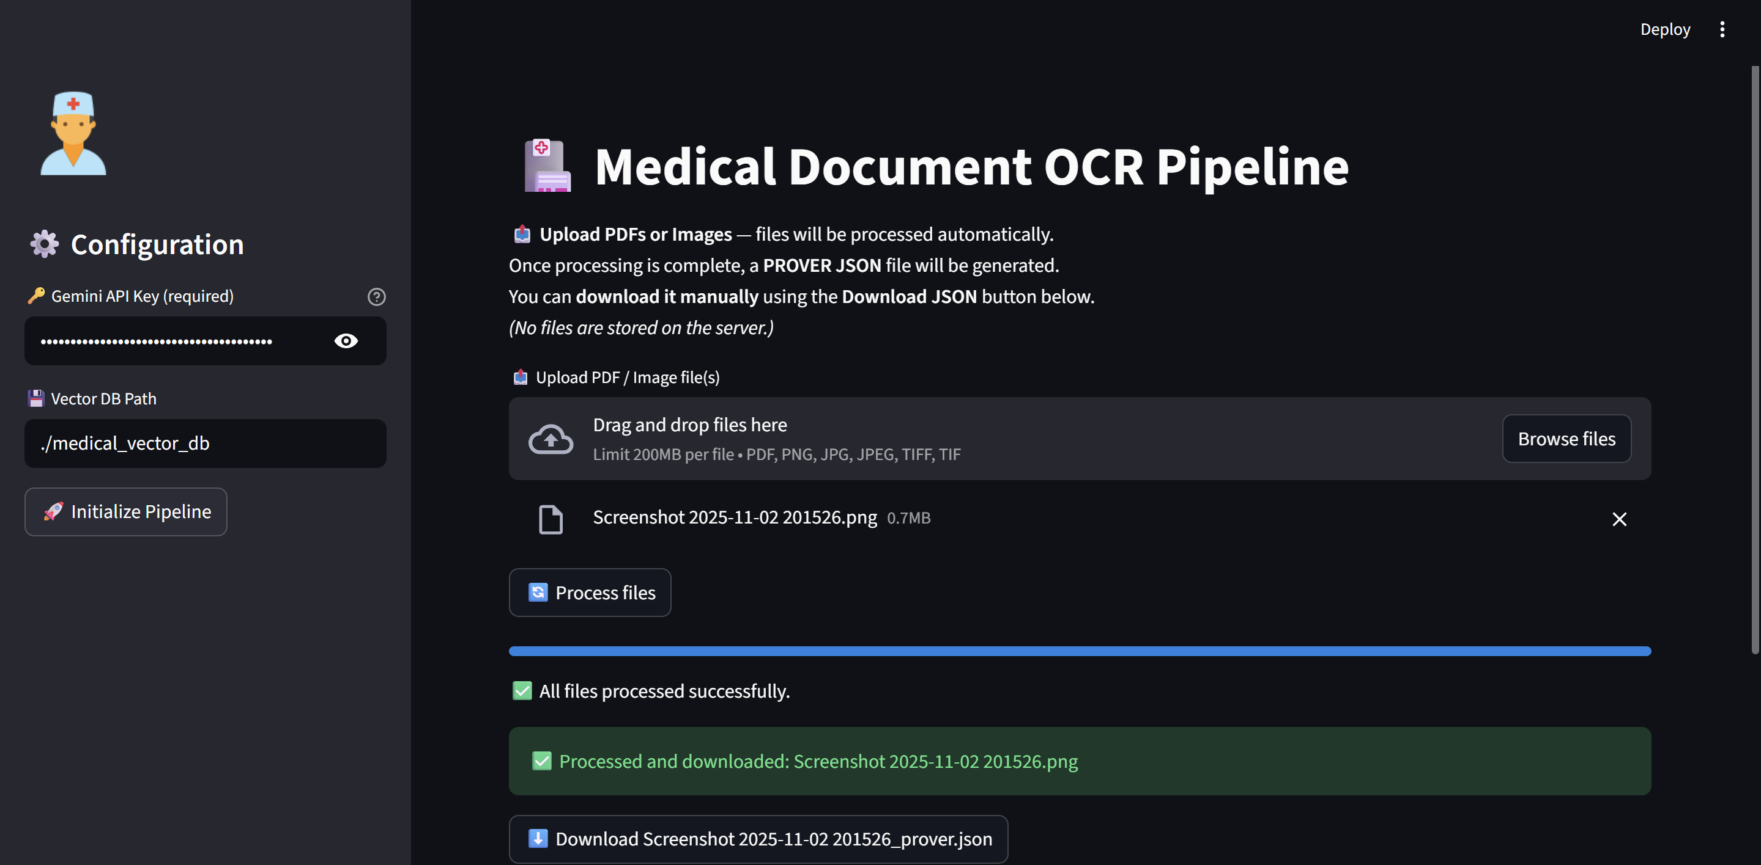
Just press on below button Download screenshot and data will be downloaded to your system

Downloaded json file :- https://drive.google.com/file/d/11RBx-a7gDu23MZd17qGSsckneUdj1WBk/view?usp=sharing

